BFA Acting Auditions for Class Beginning in the Fall of 2019

Auditions for current high school students wishing to be considered for acceptance into the BFA in Acting program at UNCG entering the fall of 2019 will take place on these dates:

November 9, 2018 (Friday)
February 15, 2019 (Friday)
February 22, 2019 (Friday)

Join us for a day on campus. The day will include
-a group meeting (including time for questions) with the all those auditioning, the head of the School of Theatre, the BFA Acting coordinators, representatives from the financial aid and housing offices, and current BFA Acting students.
-A master class to let you see some of the work we are doing.
-Individual auditions. 2 contrasting monologues totaling no more than 3 minutes total (total time for both monologues) followed by a short interview*.
-Stay for a UNCG show at 7:30pm (complimentary tickets for you and your family provided).

*The audition/interview is the only thing you are required to attend. We hope you can make it to all the different opportunities on your audition day. The auditions will be in ten minute slots so there won’t be time for discussion during this short period.

For more information, or to schedule your audition, email Christine Morris & Michael Flannery at bfaact@uncg.edu.

Acting Alums include:
Chris Chalk, Fences (Broadway), Gotham,12 Years a Slave, Detroit, The Central Park Five
Beth Leavel, The Drowsy Chaperone (Broadway + Tony Award, Best Actress in a Musical), Bandstand (Broadway), Mama Mia (Broadway), The Prom (Broadway)
Brandon Ellis, Bandstand (Broadway, Once (Broadway), Company (Broadway), The Play that Goes Wrong (National Tour)
Tyler Barnhardt, Bull, Scorpion, Turn, Underground, The Jury, Suspicion
Jennifer Mann, House of Cards, The Disappointments Room
Alex Marshall-Brown, New Girl, This is Us, Scandal, Modern Family
Michael Tourek, Ozark, Resurrection, The Producers, John Adams, Sleepy Hollow
Ashlei Sharpe Chestnut, A Doll's House, part 2 (Broadway), The Crucible (Broadway), Homeland, Panic
Caity Brewer, The Choice, Homeland,Laura Gets A Cat
Olivia Griffin, Dead Silent, Shadow of a Doubt

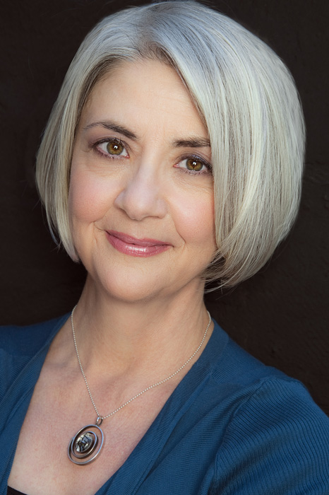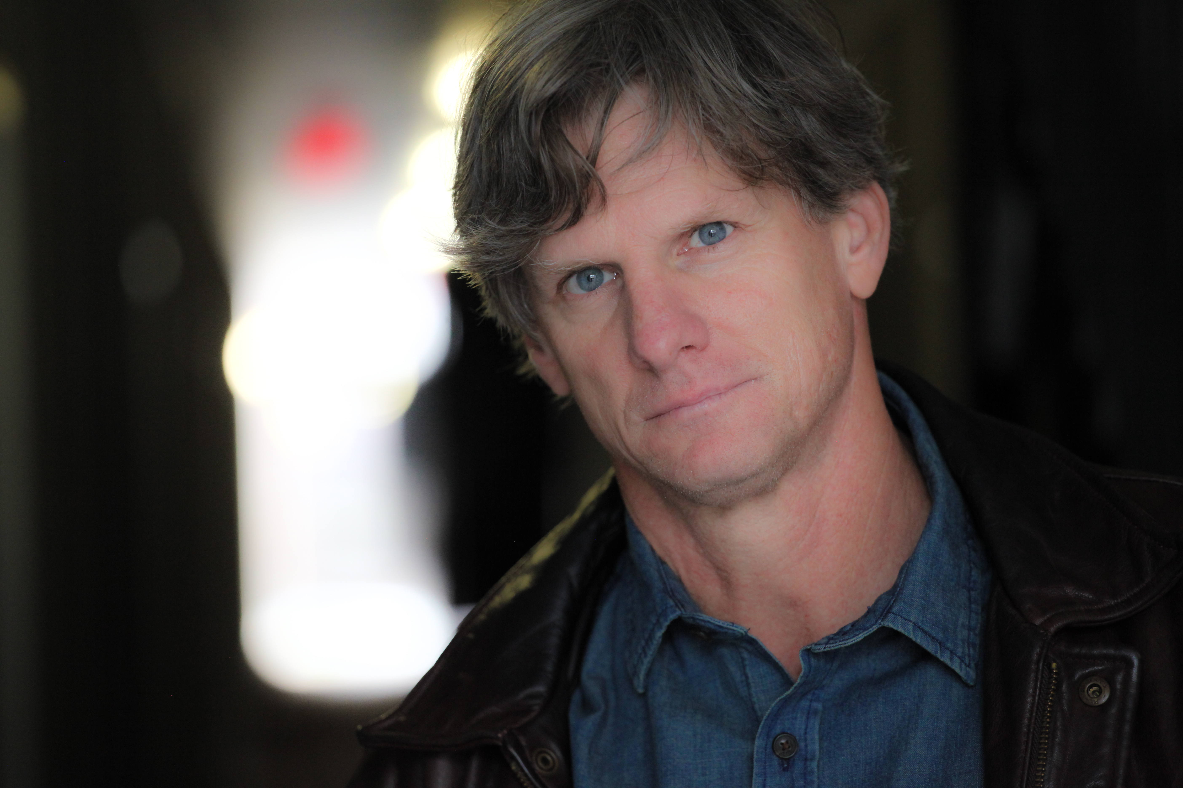

Christine Morris Michael Flannery
Associate Professor Associate Professor
Co-coordinator, BFA in Acting Program Co-coordinator, BFA in Acting Program
Email: bfaact@uncg.edu, or camorri4@uncg.edu Email: bfaact@uncg.edu, or flannery@uncg.edu

